IDEATION PHASE
Define the Problem Statements
HotelPro – Hotel Room Booking and Management System

Date | 16 October 2026
Team ID:
Project Name | HotelPro – Hotel Room Booking and Management System
Maximum Marks | 2 Marks
Customer Problem Statement Template:
To define the core problems travellers, hotel receptionists and administrators face when searching for, booking and managing hotel rooms online, and use those insights to guide the development of HotelPro.
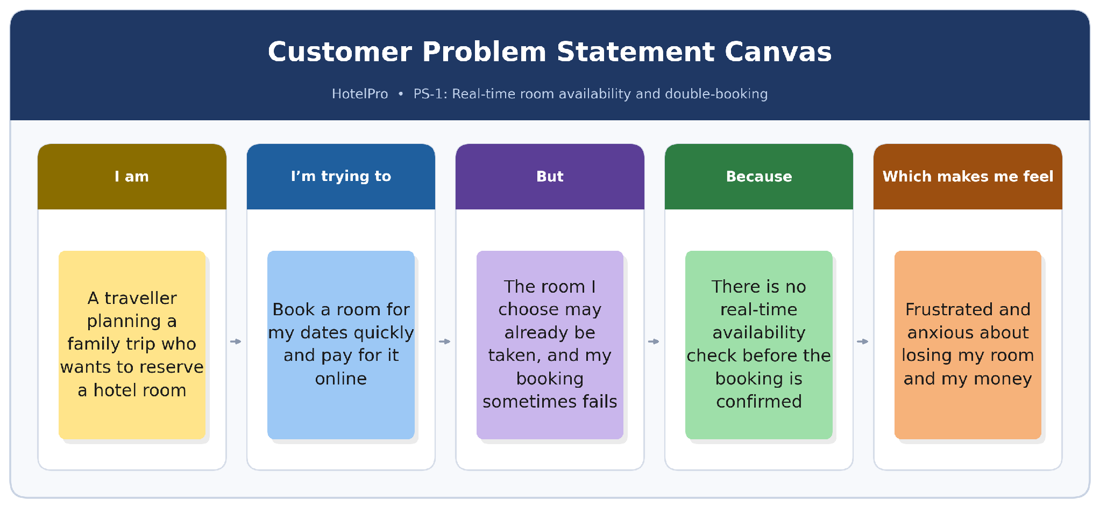
Figure 1 – Customer problem statement canvas for PS-1 (traveller booking a room)
Reference: FREE Customer Problem Statement Template | Miro 2026
Problem Statements
Problem Statement (PS) | I am (Customer) | I'm trying to | But | Because | Which makes me feel
PS-1 | a traveller planning a family trip | book a hotel room for my dates and pay online | the room I choose may already be taken and my booking sometimes fails | there is no real-time availability check before the booking is confirmed | frustrated and anxious about losing my room and my money.
PS-2 | a customer looking for a hotel in a new city | find suitable hotels and rooms by city, dates, price and room type in one place | I have to compare several websites and cannot easily filter the results | listings are scattered and search and filter options are weak | annoyed and that I am wasting time.
PS-3 | a customer whose travel plans have changed | cancel or modify my booking and know the status of my payment or refund | the cancellation rules and refund status are unclear | policies are hidden and payments and refunds are not tracked | worried and unsure whether I can trust the service.
PS-4 | a hotel receptionist handling arrivals and departures | check guests in and out and keep accurate guest records | I rely on paper registers and room status is not updated on time | bookings, guest details and room status are not linked in one system | stressed and prone to errors at the front desk.
PS-5 | a hotel administrator managing rooms and rates | keep hotel details, room types, prices and room status up to date | rooms are sometimes shown as available when they are occupied or under maintenance | inventory is managed manually and there is no central management tool | worried about lost revenue and unhappy guests.
PS-6 | a platform administrator | monitor bookings, payments, users and revenue | data is spread out and difficult to review | there is no central dashboard or role-based access to reports | overwhelmed and slow to respond to problems.
Table 1 – Customer problem statements for HotelPro (PS-1 to PS-6)

Traceability to the HotelPro SRS
Each problem statement above is addressed by specific functional requirements in the HotelPro Software Requirements Specification, as shown below.
PS | User Class | HotelPro SRS Section | Key Requirement IDs
PS-1 | Customer | 3.4 Room Search and Availability; 3.5 Hotel Room Booking | FR-SRC-03, FR-BKG-03, FR-BKG-05, FR-PAY-04
PS-2 | Customer | 3.4 Room Search and Availability | FR-SRC-01, FR-SRC-02, FR-SRC-04
PS-3 | Customer | 3.6 Booking Management; 3.9 Payment Processing | FR-BMG-02, FR-BMG-05, FR-PAY-03, FR-PAY-05
PS-4 | Hotel Staff | 3.7 Guest Management; 3.8 Check-in and Check-out | FR-GST-01, FR-GST-02, FR-CIO-01 to FR-CIO-03
PS-5 | Administrator | 3.3 Hotel and Room Management | FR-HRM-01 to FR-HRM-05
PS-6 | Administrator | 3.10 Admin Dashboard; 3.2 JWT-Based Authentication | FR-ADM-01, FR-ADM-03, FR-ADM-04, FR-JWT-05
Table 2 – Mapping of problem statements to SRS sections and requirement IDs

